**Modelling the effects of livestock antibiotic usage on human foodborne disease**

**ABSTRACT**

Livestock antibiotic usage has been proposed as a major driver of antimicrobial resistance in human populations. This has contributed to the implementation of antibiotic stewardship programs aiming to curtail usage of livestock antibiotics. However, the possible consequences of livestock antibiotic curtailment on human health are poorly understood. In particular, there is the potential for increases in the carriage of foodborne pathogens in livestock due to a loss of antibiotic pressure, and subsequent increase in human foodborne disease. Here we use a mathematical model to explore the impact of curtailing livestock antibiotic usage on both antibiotic-sensitive and antibiotic-resistant foodborne disease in humans.

The model identified increases in the daily incidence of human foodborne disease and a decrease in resistant human foodborne disease following livestock antibiotic curtailment. However, these effects can be mitigated through interventions to reduce animal-to-human transmission by targeting the farm-to-fork pathway. The magnitude of interventions needed to mitigate increases in human foodborne disease were found to vary across different case studies, suggesting that a “one-size fits all approach” across different agricultural settings, livestock hosts, and drug/bug combinations will likely not be efficacious.

This study provides a motivating example of one of many plausible scenarios following livestock antibiotic curtailment and identifies that even if increases in human foodborne disease are observed, existing agricultural biosecurity interventions can successfully mitigate the negative human health consequences of livestock antibiotic curtailment.

**INTRODUCTION**

Antimicrobial resistance (AMR) is currently one of the largest threats to human health, with a growing number of key antibiotic therapeutics being rendered ineffective by resistant bacterial pathogens. Livestock antibiotic usage has been identified as a potentially important driver of AMR in human populations, with cross-species transmission of resistant bacteria and resistance determinants potentially occurring at the livestock/human interface (1). This has led to calls to curtail the usage of livestock antibiotics, with legislature such as the 2006 European Union ban and 2017 US Food Drug Administration regulation on antibiotic growth promotion, aiming to safeguard the efficacy of clinical antibiotics and reduce the potential for transmission of resistant pathogens to human populations (2, 3).

A range of beneficial outcomes have been reported as a consequence of livestock antibiotic curtailment, including decreased faecal *Enterococci* resistance rates in Denmark and Germany resulting from the 2006 growth promotion ban (2, 4, 5). Transient increases in the carriage of other resistant pathogens, increases in livestock carriage of foodborne pathogens and increases in therapeutic livestock antibiotic usage following antibiotic curtailment has also been identified in AMR literature (6). These negative consequences have been suggested to be attributable to increases in livestock production in the years following the European ban on antibiotic-mediated growth promotion and due to other resistance-related genetic factors (7, 8). However, the unforeseen nature of these potential consequences highlights the risks of introducing substantial interventions into highly complex and poorly understood systems as part of a “precautionary principle” based approach (9). The need to better understand the potential long-term impacts of future AMR policy is also likely to increase in coming years, with new EU legislation strictly controlling the use of livestock antibiotics for metaphylaxis or prophylaxis by 2022 (10). However, the precise relationship between livestock antibiotic usage and antibiotic-resistant/sensitive human foodborne disease remains poorly understood (5).

One approach to better understand the complexities of livestock antibiotic usage includes the use of mathematical models. These models can help by testing uncertainties, especially regarding the potential effects of livestock antibiotic usage on human health and the extent of AMR transmission at the livestock/human interface. However, there is a severe dearth of models which quantitatively explore these uncertainties (11). Existing frameworks include predictive risk assessment models and a small number of generalised deterministic models (12-17). Nevertheless, a significant number of knowledge gaps still exist, including a lack of understanding of the potential consequences resulting from livestock antibiotic curtailment and the impact of different mitigating scenarios on altering these outcomes (18).

To address some of the gaps in AMR modelling literature, a deterministic mathematical model was developed to explore the effects of livestock antibiotic curtailment on common foodborne infections in humans across a range of scenarios. By explicitly modelling both livestock/human populations and various assumptions regarding the effects of livestock antibiotic usage, we will explore the potential long-term consequences of livestock antibiotic curtailment, including alterations to the overall incidence of human foodborne disease and the antibiotic-resistant fraction of infections. Additionally, we will explore the effects and feasibility of introducing interventions to mitigate the potential negative consequences of livestock antibiotic curtailment.

**METHODOLOGY**

**Model Structure and Description**

A deterministic compartmental model was developed to describe the transmission of antibiotic-resistant and antibiotic-sensitive foodborne bacteria within and between livestock and human populations (Figure 1) (19). Each host population can be stratified based on their respective infection status: susceptible humans (SH), humans infected with antibiotic-sensitive bacteria (ISH), humans infected with antibiotic-resistant bacteria (IRH), susceptible livestock food-animals (SA), livestock food-animals infected with antibiotic-sensitive bacteria (ISA) and livestock food-animals infected with antibiotic-resistant bacteria (IRA).

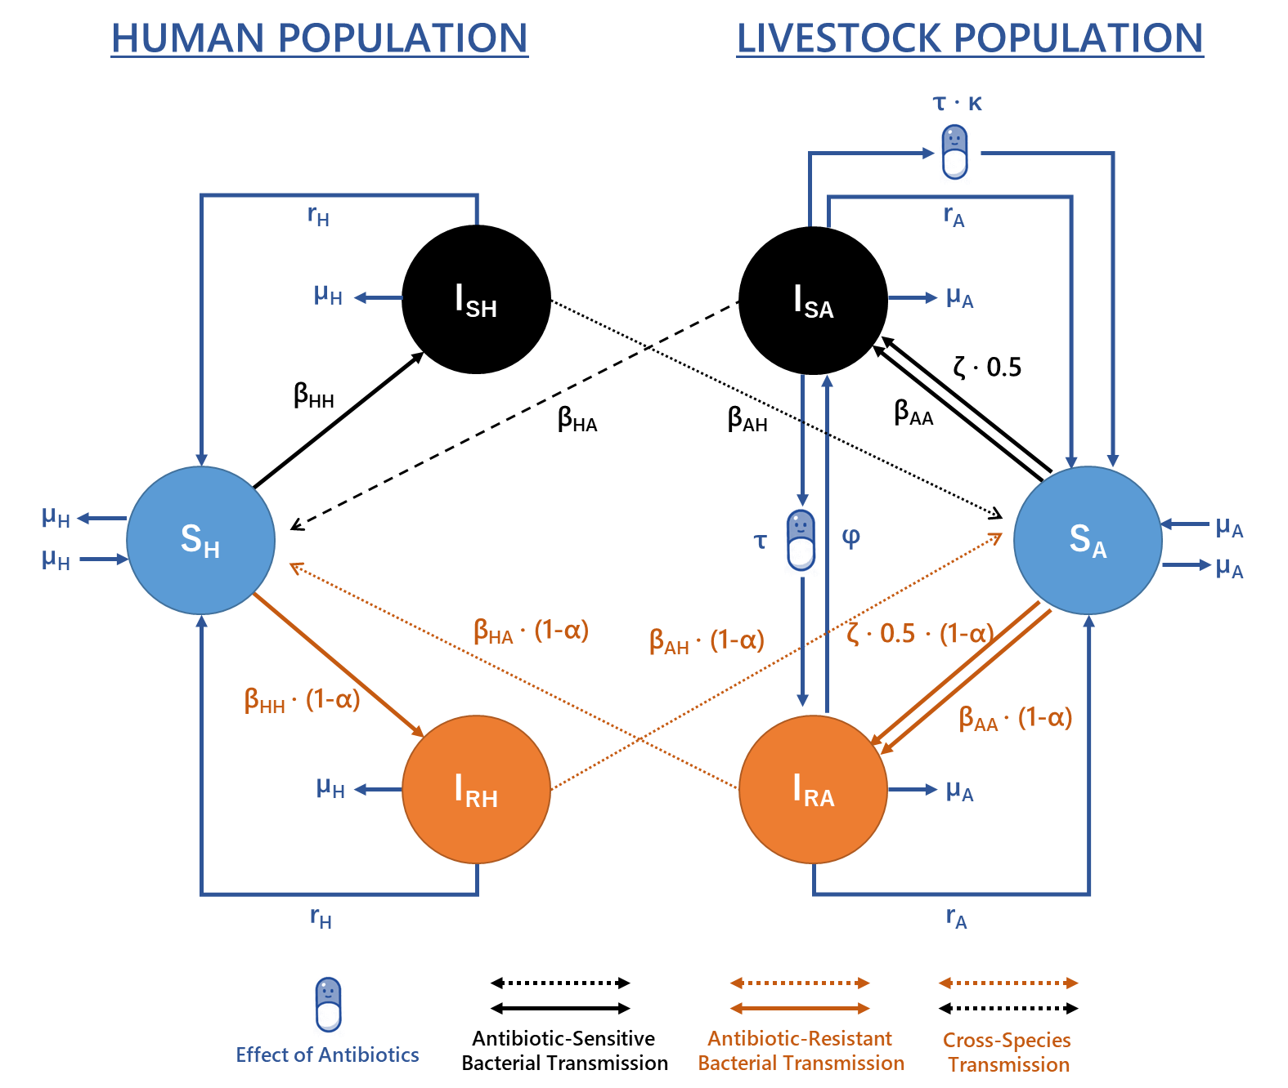

**Figure 1. Model structure describing the transmission of foodborne pathogens between/within livestock and human populations.** Model equations and parameters can be found described in the supplementary material (Table S2).

Transmission is simplified into four transmission routes: animal-to-animal (βAA), human-to-human (βHH), animal-to-human (βHA) and human-to-animal (βAH) transmission, with each β parameter linearly describing both indirect and direct transmission between compartments for model tractability. A background rate of transmission in the livestock population was also modelled (ζ); representing infection/contamination of livestock hosts from sources other than other livestock or humans. This generalised background transmission rate was scaled by a factor of 0.5 to ensure an equal influence of ζ on both antibiotic-sensitive and resistant transmission routes. Natural recovery from antibiotic-sensitive/resistant infection occurs in both human/livestock populations at rate rH and rArespectively. Per capita birth/death rates are represented by µA in livestock and µH in human populations.

We use a simplified parameter (τ) to describe the selective pressure and therapeutic effect of livestock antibiotic usage. We model the selective pressure of livestock antibiotics as a single transition rate, encompassing a range of evolutionary and biological phenomena that convert livestock between antibiotic-sensitive to resistant states. One plausible mechanism includes an implicit majority-minority relationship in each infected state, with livestock in each infected compartment possessing a small proportion of bacteria belonging to the other susceptibility class. Subsequent antibiotic usage may therefore clear antibiotic-sensitive bacteria (ISA) and allow the minority antibiotic-resistant strain to proliferate and dominate (IRA) (12). We similarly model a single reversion parameter (φ) to encompass a range of different biologically plausible phenomena that may cause reversion of antibiotic-resistant (IRA) to sensitive strains (ISA). This includes the potential for resistant strains to gain acquire of develop de novo compensatory mutations to reduce fitness costs (20).

To reduce the linearity associated with livestock antibiotic usage on both livestock recovery and antibiotic-resistance conversion, a scaling parameter was introduced (κ) to model the relative efficacy of antibiotic mediated recovery in livestock. Transmission-related fitness costs associated with antibiotic-resistance were included and assumed to reduce the rate of transmission for antibiotic-resistant bacteria as a scaling factor (α).

**Primary outcome measures**

Two primary outcome measures were considered in this study: 1) the daily incidence of human non-typhoidal salmonellosis per 100,000 population in the EU, defined as the sum of the daily incidence of antibiotic-sensitive and resistant infections at the long-term non-zero steady state. This required a scaling transformation to convert the model output daily prevalence/proportion infected to the daily incidence infected using EU population data (supplementary material). 2) The fraction of antibiotic-resistant human non-typhoidal salmonellosis (I*­RHProp) (defined as IRH / (ISH+IRH) at the long-term non-zero steady state. This quantity was directly calculated from the ODE solver output.

The long-term non-zero steady state of the two previously defined quantities was calculated using the “rootSolve” package, which dynamically solves the ODEs numerically until the calculated derivatives are determined to be at steady state. Although we note that it is likely that the current dynamics of AMR are in flux due to the influence of ongoing interventions, studying it at equilibrium is a useful indication of the long-term dynamics of the AMR and where the system is heading. This is especially the case for resistant *Salmonella* spp. infections, with a short duration of infectious human carriage (1/rH), facilitating a rapid approach to equilibrium. This approach is also justified with temporal surveillance data suggesting the proportion of antibiotic resistance in livestock populations has stabilised at relatively constant levels in recent years (Figure S2-3).

**Model parameterisation and case studies**

An approximate Bayesian computation sequential Monte-Carlo (ABC-SMC) approach was used for parameter estimation. Summary statistics and distance functions were used to estimate the posterior probability distribution given the data, $P(θ|x_{d})$. Detailed methodology and pseudo-code of the ABC-SMC approach can be found in Toni et al, (2009) (21).

We note that while the primary outcome measures are relevant for humans (incidence and I*­RHProp), the model also simulates the relationship between livestock antibiotic usage and the fraction of antibiotic-resistant livestock infection. We can fit this livestock portion of the model to surveillance data, to ensure that modelled livestock interventions occur in livestock populations with realistic dynamics. Four case studies were chosen to aid model parameterisation and to ground the model with EU epidemiological surveillance data. These case studies were: 1) ampicillin-resistant non-typhoidal salmonella in broiler poultry to humans from 2014-2018, 2) tetracycline-resistant non-typhoidal salmonella in broiler poultry to humans from 2014-2018, 3) ampicillin-resistant non-typhoidal salmonella in fattening pigs to humans from 2015-2018 and 4) tetracycline-resistant non-typhoidal salmonella in fattening pigs to humans from 2015-2018 (22-27) (Figure 2).

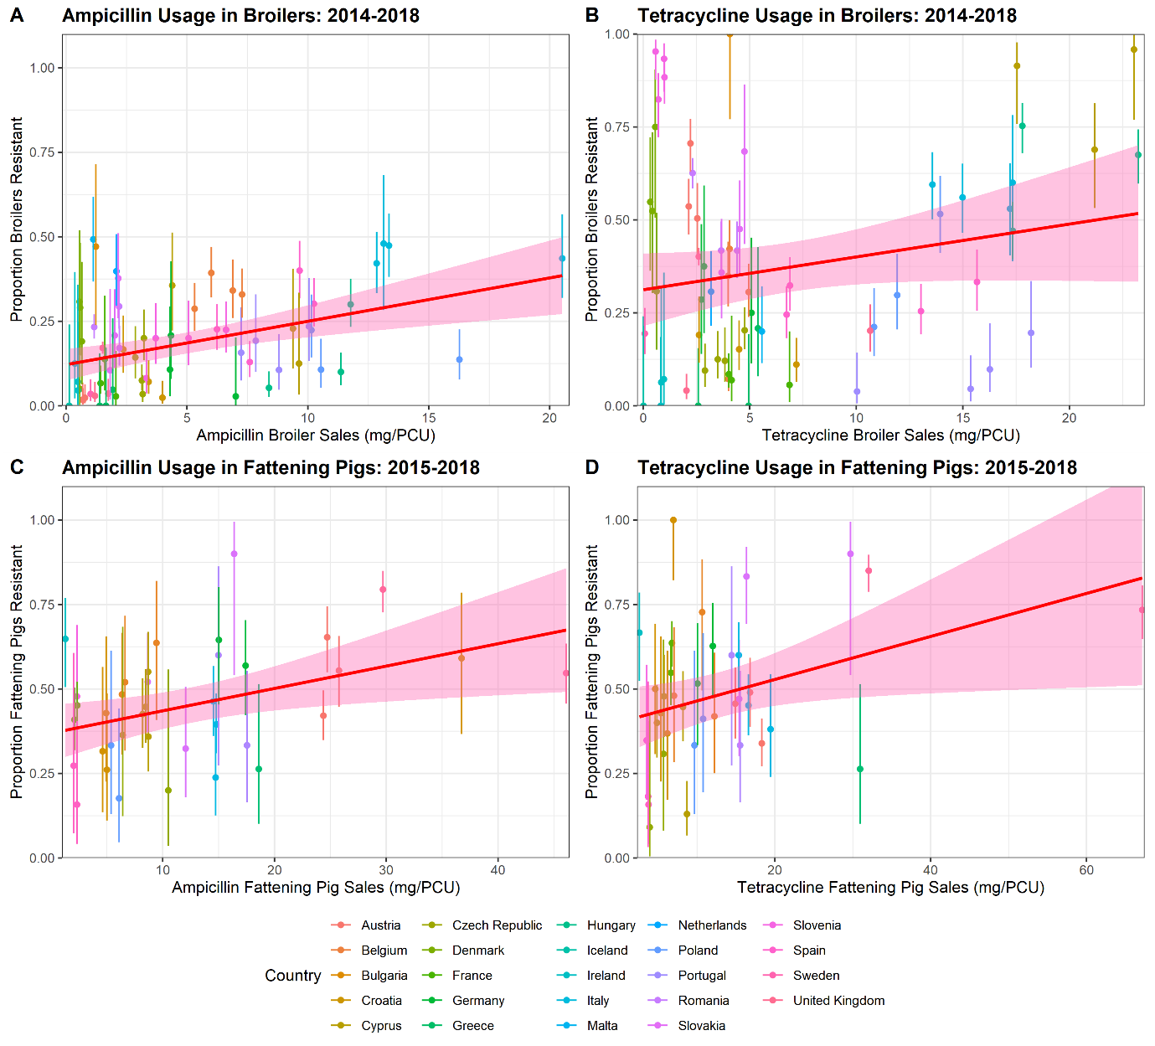

**Figure 2. Relationship between scaled antibiotic sales and the proportion of isolates resistant across different EU country/year pairs from 2014-2018. A) Ampicillin-resistance in broiler poultry, B) tetracycline-resistance in broiler poultry, C) ampicillin-resistance in fattening pigs and D) tetracycline-resistance in fattening pigs.** Solid line and ribbons represent the best fitting linear regression between sales and resistance with 95% CIs for model predictions. We note that only the tetracycline usage in broilers case study was non-significant.

These four case studies were chosen due to the high level of usage (both historical and current) of tetracycline and ampicillin in broiler poultry and fattening pigs, and the availability of resistance data for these two livestock species (28-32). We justify exploring the relationship between sales/usage and resistance for these four case studies as the basis for the model fitting and parameterisation in this study, due to the observed statistically significant relationship between the two variables for three out of four included case studies, with one case study exhibiting a borderline significant relationship (Figure 2).

**Datasets and livestock parameterisation**

Yearly ESVAC data for livestock antibiotic sales and EFSA data on the proportion of *Salmonella* spp. isolates obtained from livestock species resistant to the tetracycline/ampicillin were used to create usage/sales and livestock resistance pairs for each country in each respective case study (22-27, 29-33). These pairs spanned across multiple years for each country (Figure S2-5). Therefore, for any one country, there may be multiple usage/resistance pairs corresponding to different years in the dataset. These pairs were used to determine the observed relationship between livestock antibiotic sales/usage and the fraction of antibiotic-resistant livestock infection in European countries between 2014-2018 for each respective livestock species.

It is important to note that the stratification of each country into their respective yearly data for each data point introduces an assumption that the level of antibiotic usage will also be representative of resistance for a particular year. Due to the existence of lag between the effects of antibiotic stewardship interventions and alterations in either human or livestock resistance (34), it is important to ensure that there are relative levels of stability in the yearly usage and resistance for each country. We note that for the majority of included countries, this temporal stability for each country across included yearly data points was observed (Figure S2-5).

A simulated dataset for each case study was generated by modelling the fraction of antibiotic resistant livestock infections for each country/year observation, given the observed level of antibiotic sales for each country/year included in the dataset. A sum of squared errors distance function was then used to minimise the distance between the simulated ($x$) and observed ($x_{d}$) fraction of antibiotic-resistant livestock infection for each country/year data point. The number of country/year data points in each case study is denoted by $n$.

$$d\left(x, x_{d}\right)=\sum_{i}^{n}{{(x\left[i\right]-x_{d}[i])}^{2}}$$

ESVAC antibiotic sales data is found averaged for all livestock species in each country in the original surveillance report. A scaling calculation was therefore required to convert the generic antibiotic sales to a value specific to the modelled livestock host. Details of this can be found in the supplementary information. Note that due to a lack of accurate country-level antibiotic usage data, sales were assumed to be a proxy for usage. Mentions of “usage” are therefore in reference to the ESVAC sales data. In accordance with the EFSA guidelines, countries with <10 isolates in the respective EFSA dataset for a particular year were omitted from the model fit to preserve the integrity of the dataset when fitting (22-27).

**Human summary statistics**

Two additional summary statistics were also used: 1) minimise the difference between the modelled daily EU incidence of human salmonellosis at baseline antibiotic usage and the observed ECDC daily EU incidence of human salmonellosis currently observed (0.593 per 100,000), 2) minimise the difference between the model estimated proportion of resistant human salmonellosis at baseline antibiotic usage and the EFSA averaged European proportion of resistant human salmonellosis specific for each case study. The baseline antibiotic usage for each case study was considered the unweighted average tetracycline/ampicillin sales across each included antibiotic country/year data point. 1) Ampicillin-resistance in broiler poultry (0.0049 g/PCU), 2) tetracycline-resistance in broiler poultry (0.0069 g/PCU), 3) ampicillin-resistance in fattening pigs (0.0125 g/PCU) and 4) tetracycline-resistance in fattening pigs (0.01305 g/PCU).

**ABC-SMC model fitting**

The ABC-SMC approach was used estimate the marginal posterior probability distribution for six model parameters (θ) given the data. Other model parameters were not fitted as estimates with high levels of certainty were available (rH, rA, μA and μH), or due to the relative nature of other transmission parameters with respect to βAA, βHA and ζ (βHH and βAH). These latter parameters were instead held at static values. Prior distributions for each fitted parameter can be found in the supplementary material (Table S3).

The ABC-SMC model fit was run for ten generations, with each generation running until the acceptance of 1000 particles. Acceptance thresholds (ε) can be found in thesupplementary material (Table S4). A multivariate normal distribution was chosen for the ABC-SMC perturbation kernel (21), with the randomly sampled mean and covariance matrix calculated from the previously accepted generation of accepted particles.

Mean point estimates from the approximated marginal posterior probability distributions of the 10th accepted generation were used as the final parameter sets for each respective case study. Point estimates and calculated 95% HDIs from the marginal posterior distribution for each model parameter can be found in the supplementary material (Table S2).

**Sensitivity Analysis**

A Fourier amplitude sensitivity test (FAST) approach was used to conduct a sensitivity analysis of the model system to the model parameters with regards to two outcome measures (35): 1) the daily incidence of human foodborne infection and 2) proportion of resistant human infection. The parameter space range chosen for the sensitivity analysis was limited to an order of magnitude above and below the parameterised values. For fitted model parameters, this range was taken as an order of magnitude above and below the mean of the fitted point estimate for each parameter across each considered case study.

The FAST approach was also used to identify the sensitivity of the model system to two intervention related outcome measures: 1) Relative changes in daily incidence when livestock antibiotics were curtailed (*τ* = 0 g/population correction unit (PCU)), compared to daily incidence at mean baseline livestock antibiotic usage across the four case studies (*τ* = 0.00934 g/PCU) and 2) Relative changes in daily incidence under antibiotic curtailment (0 g/PCU) relative to what is currently observed with current levels of antibiotic usage (0.593 per 100,000). An in-depth description of this sensitivity analysis can be found in the supplementary material.

**RESULTS**

The relationship between observed country-level antibiotic usage data and livestock tetracycline/ampicillin-resistance surveillance data was plotted for all four case studies, with the model output overlaid, parameterised using ESVAC/EFSA data (Figure 3). It is important to note that the existence of the ζ parameter (ζ > 0) is necessary to prevent I*RHProp decreasing to 0 upon livestock antibiotic curtailment. Inclusion of the ζ parameter was shown to provide a better fit to the model compared to a null model with ζ = 0 (supplementary material; Figure S1). Approximated marginal posterior probability distributions for the fitted model parameters from the ABC-SMC approach can be found in the supplementary material (Figure S6).

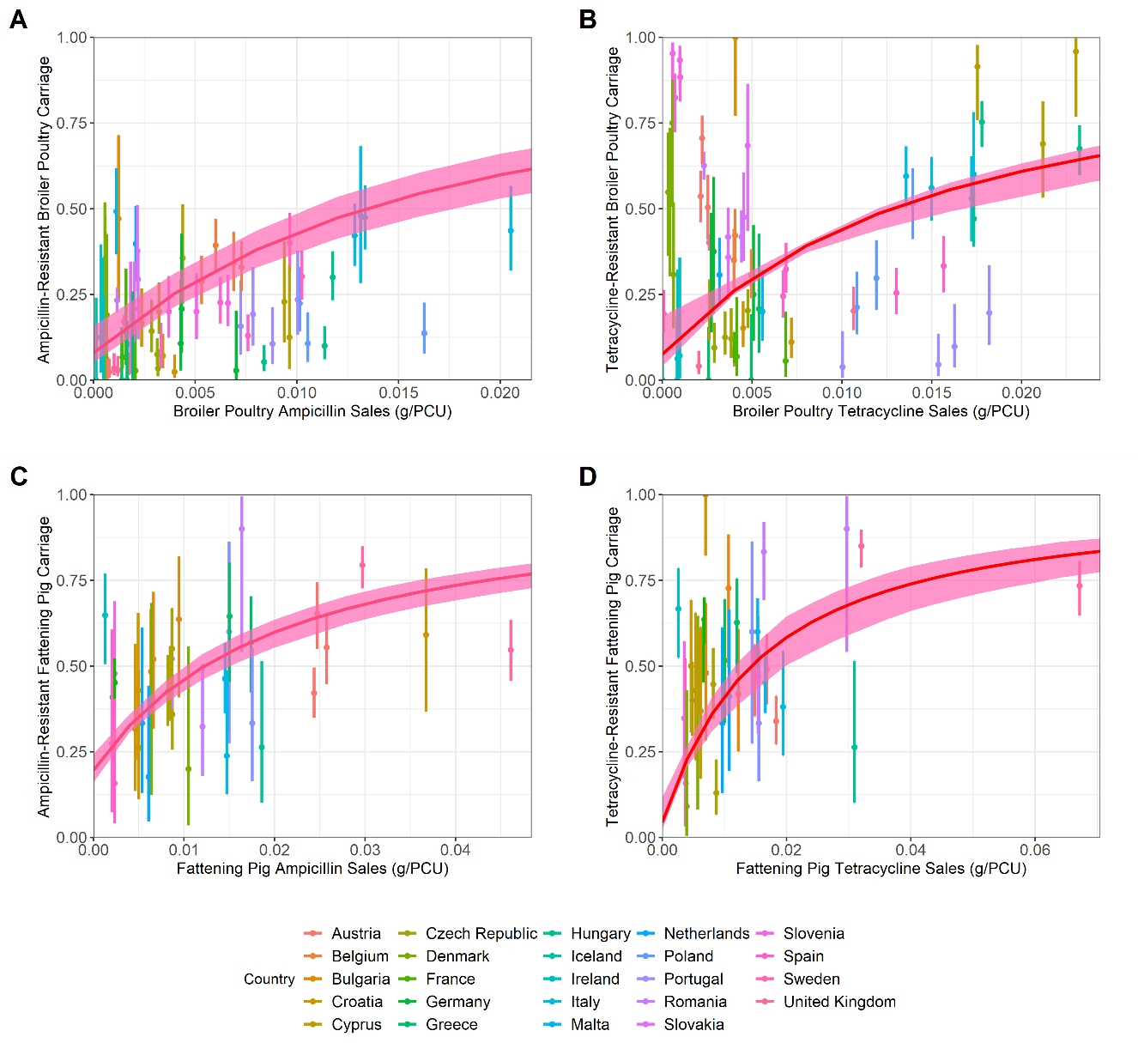

**Figure 3. Observed and estimated relationship between livestock antibiotic usage data and antimicrobial-resistant salmonellosis in humans. A) Ampicillin-resistance in broiler poultry, B) tetracycline-resistance in broiler poultry, C) ampicillin-resistance in fattening pigs and D) tetracycline-resistance in fattening pigs.** Solid red lines and ribbons represent model fit resulting from the approximated posterior distribution using ABC-SMC and the corresponding 95%. Country-specific 95% confidence intervals for the observed data (dots) were calculated for each case study using a 1-sample proportion test with continuity correction.

A Fourier amplitude sensitivity testing (FAST) approach was used to explore the sensitivity of the daily incidence of salmonellosis and I*RHProp outcome measures to the model parameters. The most influential parameters for the daily incidence of salmonellosis were identified as the rate of animal-to-human transmission (βHA), with other parameters having a substantially reduced impact, and with I*RHProp being most sensitive to transmission-related fitness costs (α), livestock antibiotic usage (τ), the efficacy of antibiotic-mediated recovery in livestock (κ) and antibiotic-resistant to antibiotic-sensitive reversion rate (φ) (Figure S7).

Using the fitted parameter values, the overall EU averaged daily incidence of human salmonellosis and the daily proportion of antibiotic-resistant human salmonellosis (I*RHProp) was modelled at: 0.593 per 100,000 population and 0.35 for the ampicillin-resistant human salmonellosis from the broiler poultry case study at baseline ampicillin usage (τ = 0.0049 g/PCU). 0.593 per 100,000 population and 0.31 for the tetracycline-resistant human salmonellosis from the broiler poultry case study at baseline tetracycline usage (τ = 0.0069 g/PCU). 0.593 per 100,000 population and 0.31 for the ampicillin-resistant human salmonellosis from the fattening pigs case study at baseline ampicillin usage (τ = 0.0125 g/PCU). 0.593 per 100,000 population and 0.30 for the tetracycline-resistant human salmonellosis from the fattening pigs case study at baseline tetracycline usage (τ = 0.01305 g/PCU) (Figure 4).

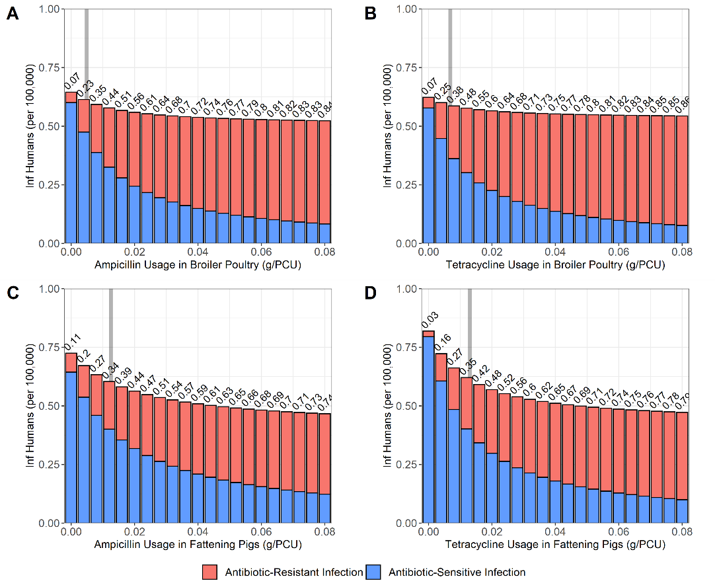

**Figure 4. Impact of alterations in livestock antibiotic usage (τ) on the daily incidence of salmonellosis and the proportion of resistant human infection (I*RHProp).** A) Ampicillin-resistant human salmonellosis from broiler poultry. B) Tetracycline-resistant human salmonellosis from broiler poultry. C) Ampicillin-resistant human salmonellosis from fattening pigs. D) Tetracycline-resistant human salmonellosis from fattening pigs. Grey bar denotes the case study specific baseline livestock antibiotic usage. Numbers above the bars denote I*RHProp.

Curtailment of livestock antibiotic usage (τ → 0 g/PCU) resulted in small increases in the daily incidence relative to at baseline antibiotic usage levels across all case studies (Figure 4). Curtailment in the fattening pigs case studies resulted in the largest increase in the daily incidence with a X-fold (X per 100,000) increase relative to baseline levels, and an X-fold (X per 100,000) for the ampicillin and tetracycline case studies respectively. Increases in the daily incidence for the broiler poultry case studies were relatively milder with an X-fold (X per 100,000) and an X-fold (X per 100,000) increase in the daily incidence for the ampicillin and tetracycline usage case studies respectively. Increases in livestock antibiotic usage above baseline usage levels in the four case studies resulted in the opposite phenomenon being observed, with small decreases in overall human foodborne disease and increases in the proportion of resistant infection.

We next identified the parameters which had the greatest influence on relative increases in the daily incidence when livestock antibiotics were curtailed, compared to daily incidence at mean baseline livestock antibiotic usage across the four case studies (τ = 0.00934 g/PCU) (Figure 5A). Therefore, parameters that are identified as influential are those that result in scenarios where curtailing livestock antibiotic usage has a greater relative increase in daily incidence. Daily incidence at mean baseline livestock antibiotic usage was allowed to vary and was not fixed across modelled parameter combination. The per capita rate of background transmission to livestock populations (ζ) and efficacy of antibiotic-mediated livestock recovery (κ) were found to be the most influential parameters in determining the relative increase in daily incidence from baseline livestock antibiotic usage when antibiotics where curtailed. (Figure 5A). Lower κ parameter values, and higher ζ parameter values resulted in lower relative increases in daily incidence when livestock antibiotics were curtailed (τ = 0 g/PCU) (Figure S8).

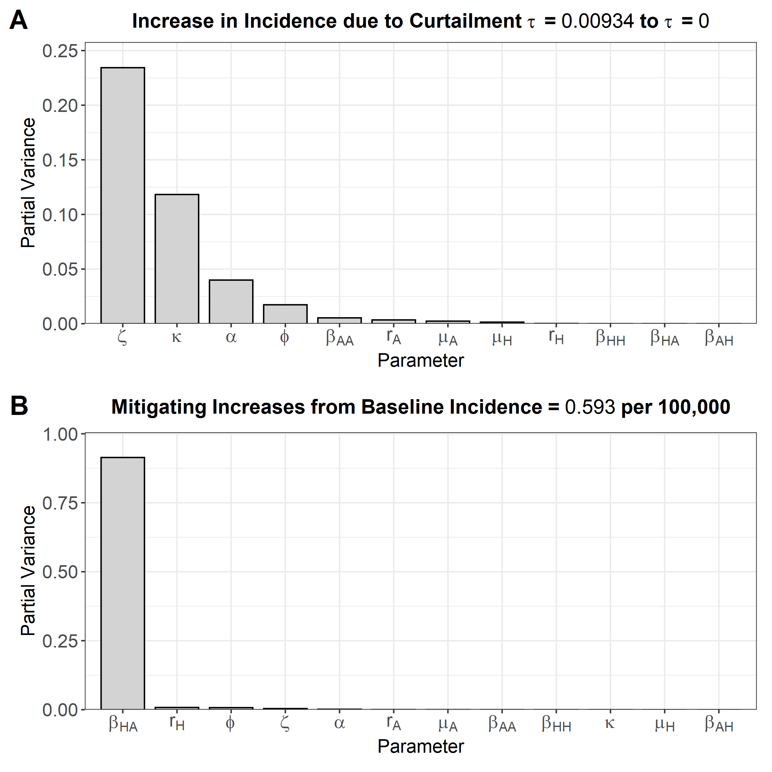

**Figure 5. Fourier amplitude senstivity test (FAST) to identify the most influential model parameter for. Higher bars indicate greater sensitivity: A) Relative change in daily incidence under curtailment (0 g/PCU) compared to the averaged baseline antibiotic usage level (0.00934 g/PCU). B) Mitigating changes in daily incidence under curtailment compared to the level of foodborne disease experienced under current levels of livestock antibiotic usage (0.593 per 100,000 population).**

A sensitivity analysis was next performed to identify parameters that could best mitigate increases in daily incidence under antibiotic curtailment (0 g/PCU) (Figure 5B). This was identified by curtailing livestock antibiotic usage and identifying model parameters that cause the greatest relative change in daily incidence from the *fixed* baseline value of 0.593 per 100,000 (the level of salmonellosis currently observed). By extension, interventions targeting these identified parameters will be more capable of reducing levels of daily incidence back down to the baseline levels currently observed.

We identified the per capita rate of animal-to-animal transmission (βHA) as the key parameter to mitigate increases in daily incidence. Intuitively, decreasing βHA leads to a non-linear decrease in the daily incidence observed (Figure S9). This therefore represents the best parameter to target to mitigate potential increases in daily incidence due to livestock antibiotic curtailment.

Alterations to βHA, βAA and ζ parameters were next explored to identify potential interventions to mitigate increases in daily incidence under antibiotic curtailment (0 g/PCU), below a threshold of 0.593 per 100,000 population. This threshold represents a removal of livestock antibiotic selection pressure (0 g/pCU) and a prevention of increases in daily incidence above what is currently observed for human salmonellosis (0.593 per 100,000). Both βAA and ζ parameters were also explored as potential intervention targets, due to their relevance in agricultural biosecurity strategies to promote livestock health and mitigate livestock disease/AMR (36, 37). A limited range of transmission parameter reductions were explored for each intervention scenarios.(0% - 30%) (Figure 6)**.**

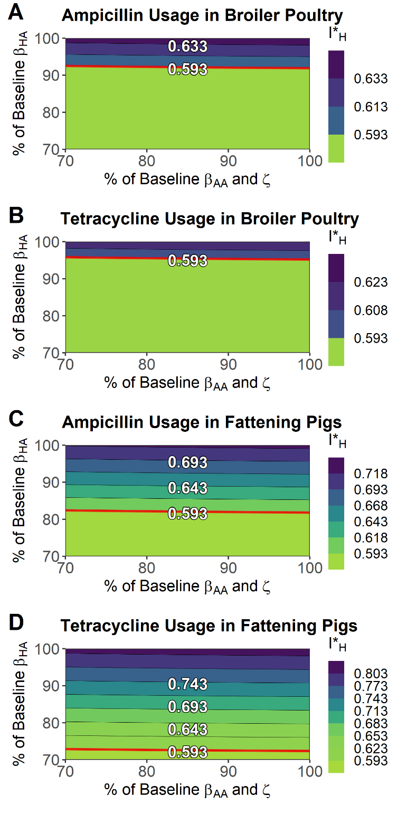

**Figure 6. Reductions to key model parameters, animal-to-human transmission (βHA), animal-to-animal transmission (βAA) and the background transmission rate to animal populations (ζ) to mitigate increases in the daily incidence of salmonellosis under livestock antibiotic curtailment (τ = 0 g/PCU). A) Ampicillin-resistance in broiler poultry, B) tetracycline-resistance in broiler poultry, C) ampicillin-resistance in fattening pigs and D) tetracycline-resistance in fattening pigs.** Axes represent interventions that reduce the labelled transmission rate(s) to % of their original values. Note that the top right corner of each contour plot represents a scenario with curtailment of antibiotics and no further alterations to any model parameter. The red line represents the threshold at which daily incidence is below current levels (0.593 per 100,000).

Only reductions to βHA were capable of mitigating increases to daily incidence below baseline levels across all considered case studies in the explored parameter space, with a reduction of X%, X %, X % and X % required for each case study (Figure 6). Isolated or even combined reductions to βAA or ζ had a negligible effect on reducing daily incidence below baseline levels across any of the considered case studies, with only a near-complete reduction βAA/ζ required to achieve mitigation below baseline (Figure S10). This corroborates the preceding sensitivity analysis suggesting that controlling animal-to-human transmission is vital to mitigate increases in daily incidence upon livestock antibiotic curtailment.

**DISCUSSION**

A deterministic compartmental model was used to identify increases in the daily incidence of non-typhoidal human salmonellosis as well as decreases in the proportion of resistant human salmonellosis following livestock antibiotic curtailment. This was explored across four relevant antibiotic/livestock case studies. Only interventions to target animal-to-human transmission routes were found to mitigate the potential increases in human salmonellosis following livestock antibiotic curtailment.

It is possible that ongoing efforts to ensure farm-level and post-harvest biosecurity have already had tangible impacts on reducing animal-to-human transmission (βHA). These efforts include increased awareness from workers in the farm-to-fork pathway to maintain good biosecurity, reduce microbial contamination on carcasses, as well as comprehensive public information campaigns to promote safe handling of food products (36, 38). However, this should not be interpreted as a suggestion that interventions to ensure livestock health should be deprioritised to favour those targeting farm-to-fork transmission routes. As evidenced by the importance of the parameter describing background levels of infection in livestock (ζ), reducing ζ by ensuring clean livestock environs and good livestock health is important to prevent large increases in daily incidence occurring when livestock antibiotics are curtailed. Although the exact contribution of these interventions on transmission have yet to be quantified, current efforts to increase livestock wellbeing, agricultural biosecurity and farm-to-fork food safety are also likely to be having an ongoing impact on preventing increases in human foodborne disease resulting from current livestock antibiotic stewardship interventions.

The ability to completely mitigate the negative human consequences of livestock antibiotic curtailment in the scenario-specific examples implemented in this study (Figure 6), also suggests that in certain cases, there may be the potential for improved biosecurity practices to replace livestock antibiotics as an alternative to prevent diseases of a livestock origin (18, 39, 40). However, further research is required to quantify the efficacy of these interventions on the specified transmission routes.

We note that there is currently no consensus in AMR literature regarding the definitive impact of antibiotic withdrawal. Therefore, the increase in foodborne disease observed in this study can be considered a hypothetical “worst case scenario” following antibiotic stewardship. However, by identifying that moderate strength biosecurity interventions are sufficient to control any detrimental human health effects following curtailment, if this “worst case scenario” is a reality, it is likely that the effects of this scenario could be mitigated.

We note that the key determinant of the increases in human foodborne disease following livestock antibiotic curtailment is the extent of antibiotic-mediated livestock recovery and transmission-related fitness costs (κ and α). As an illustrative example, preventing livestock antibiotic usage from enhancing the rate of clearance (κ = 0) and removing fitness costs (α = 0) prevents increases in livestock or consequently human foodborne disease following livestock antibiotic curtailment (Figure S11). This is consistent with several assumptions in veterinary AMR literature, which do not report detrimental human/livestock health effects following livestock antibiotic curtailment (7). Further experimental and epidemiological studies must be conducted to confirm the impact of sub-therapeutic and therapeutic antibiotic usage on the period of livestock infectious shedding and the impact of fitness costs of resistance on transmission potential.

We note that the existence of the ζ parameter prevents the model from being considered a neutral-null model (cite) due to the presence of “immigration infections” not tractable to infections at t = 0. However, the exclusion of ζ was found to result in a poorer model fit compared to where the parameter is present in the model structure (Figure S1). Additionally, as the aim of the model was not to specifically characterise the evolutionary dynamics underlying coexistence, we can justify the exclusion of a neutral-null model by implicitly acknowledging that this phenomenon exists, simplifying the mechanisms underlying coexistence and instead concentrating on the impact of host heterogeneity and zoonotic transmission on livestock AMR interventions. Future modelling into livestock antibiotic curtailment may benefit from model comparison and exploratory modelling to assess the effect of assumptions, model structure and explicit modelling of biological phenomena such as within-host AMR dynamics on the impact of modelled interventions (41).

We also note that the effort required to achieve specific reductions across different transmission parameters is likely to be asymmetrical and non-linear. Quantifying the impact of livestock interventions on transmission through future epidemiological studies would likely be necessary for further studies which aim to predict the impact of livestock interventions. Additionally, future predictive modelling is still limited by a lack of understanding of effect of farm-to-fork food processing on microbial loads and resistance (18).

We note that bans of livestock antibiotics such as avoparcin have been followed by sharp decreases in the prevalence of glycopeptide resistant *E.faecium*, therefore such trends would likely be observed if the “true” relationship between livestock antibiotic usage and livestock resistance was observed (4). However, this assumes that variation in livestock antibiotic usage is the sole driver of differences between country-level resistance in livestock. Hierarchical statistical models should be used to explore country-level effects on the prevalence of livestock antibiotic usage. We also note that in the absence of granular, country specific antibiotic usage data stratified by antibiotic and livestock, use of antibiotic sales data as a proxy is the only alternative. In the absence of higher quality surveillance data in the future, model fitting might benefit from model-based inference of livestock antibiotic usage data. There is also a dearth of high-quality livestock datasets regarding carriage of livestock resistance, especially when compared to the increasing availability and size of human datasets (42).

Due to the uncertainties with the data used in this study, it is important to note that the resulting model fit was not intended to predict the definitive consequences following alterations in livestock antibiotic usage. Rather the ABC-SMC approach was used to explore roughly parameterised case studies with the best available data, used as an illustrative example to explore the hypotheses and model structure proposed in this study. It is more useful to consider the parameterisation in this study as a method to ground the model across diverse parameter values, rather than an exact reflection of each case study. Despite the limitations of this data-driven modelling approach, we note that this is a significant improvement compared to an arbitrary parameterisation of the model system. Future improvements to AMR surveillance will likely improve the accuracy of future parameterisation of livestock AMR models (18).

This results from this study corroborates epidemiological surveillance and modelling studies, with decreases in antibiotic resistance following livestock antibiotic curtailment. However, we identify a potential increase in human foodborne disease following curtailment that may be completely mitigated through effective agricultural biosecurity interventions. The efficacy of these interventions suggests that a “one-health” attitude and an intensifying focus on improving livestock welfare to prevent human disease is critical when considering potential control strategies to tackle the AMR crisis.

**REFERENCES**

1. Woolhouse M, Ward M, van Bunnik B, Farrar J. Antimicrobial resistance in humans, livestock and the wider environment. Philos Trans R Soc Lond B Biol Sci. 2015;370(1670):20140083.

2. IP/05/1687 - Ban on antibiotics as growth promoters in animal feed enters into effect [press release]. Brussels: European Commission, 22/12/2005 2005.

3. Food U, Administration D. Guidance for Industry# 213: new animal drugs and new animal drug combination products administered in or on medicated feed or drinking water of food-producing animals: recommendations for drug sponsors for voluntarily aligning product use conditions with GFI# 209. Center for Veterinary Medicine. 2013.

4. Aarestrup FM, Seyfarth AM, Emborg HD, Pedersen K, Hendriksen RS, Bager F. Effect of abolishment of the use of antimicrobial agents for growth promotion on occurrence of antimicrobial resistance in fecal enterococci from food animals in Denmark. Antimicrob Agents Ch. 2001;45(7):2054-9.

5. Tang KL, Caffrey NP, Nóbrega DB, Cork SC, Ronksley PE, Barkema HW, et al. Restricting the use of antibiotics in food-producing animals and its associations with antibiotic resistance in food-producing animals and human beings: a systematic review and meta-analysis. The Lancet Planetary Health. 2017;1(8):e316-e27.

6. Casewell M, Friis C, Marco E, McMullin P, Phillips I. The European ban on growth-promoting antibiotics and emerging consequences for human and animal health. J Antimicrob Chemoth. 2003;52(2):159-61.

7. Schlundt J, Aarestrup FM. Commentary: Benefits and risks of antimicrobial use in food-producing animals. Frontiers in microbiology. 2017;8:181.

8. Aarestrup FM. The livestock reservoir for antimicrobial resistance: a personal view on changing patterns of risks, effects of interventions and the way forward. Philos Trans R Soc Lond B Biol Sci. 2015;370(1670):20140085.

9. Phillips I, Casewell M, Cox T, De Groot B, Friis C, Jones R, et al. Does the use of antibiotics in food animals pose a risk to human health? A critical review of published data. J Antimicrob Chemoth. 2004;53(1):28-52.

10. EUR‐Lex. Regulation (EU) 2019/6 of the European Parliament and of the Council of 11 December 2018 on veterinary medicinal products and repealing Directive 2001/82/EC. 2019.

11. Niewiadomska AM, Jayabalasingham B, Seidman JC, Willem L, Grenfell B, Spiro D, et al. Population-level mathematical modeling of antimicrobial resistance: a systematic review. BMC Med. 2019;17(1):81.

12. Spicknall IH, Foxman B, Marrs CF, Eisenberg JN. A modeling framework for the evolution and spread of antibiotic resistance: literature review and model categorization. American journal of epidemiology. 2013;178(4):508-20.

13. Caffrey N, Invik J, Waldner C, Ramsay D, Checkley S. Risk assessments evaluating foodborne antimicrobial resistance in humans: a scoping review. Microbial Risk Analysis. 2019;11:31-46.

14. Alban L, Nielsen EO, Dahl J. A human health risk assessment for macrolide-resistant Campylobacter associated with the use of macrolides in Danish pig production. Prev Vet Med. 2008;83(2):115-29.

15. Anderson SA, Woo RWY, Crawford LM. Risk assessment of the impact on human health of resistant Campylobacter jejuni from fluoroquinolone use in beef cattle. Food Control. 2001;12(1):13-25.

16. Cox LA, Jr. Potential human health benefits of antibiotics used in food animals: a case study of virginiamycin. Environ Int. 2005;31(4):549-63.

17. Hurd HS, Doores S, Hayes D, Mathew A, Maurer J, Silley P, et al. Public health consequences of macrolide use in food animals: a deterministic risk assessment. J Food Prot. 2004;67(5):980-92.

18. Marshall BM, Levy SB. Food animals and antimicrobials: impacts on human health. Clin Microbiol Rev. 2011;24(4):718-33.

19. Kermack WO, McKendrick AG. A contribution to the mathematical theory of epidemics. Proceedings of the royal society of london Series A, Containing papers of a mathematical and physical character. 1927;115(772):700-21.

20. Maisnier‐Patin S, Berg OG, Liljas L, Andersson DI. Compensatory adaptation to the deleterious effect of antibiotic resistance in Salmonella typhimurium. Mol Microbiol. 2002;46(2):355-66.

21. Toni T, Welch D, Strelkowa N, Ipsen A, Stumpf MP. Approximate Bayesian computation scheme for parameter inference and model selection in dynamical systems. J R Soc Interface. 2009;6(31):187-202.

22. Authority EFS, Prevention ECfD, Control. The European Union summary report on antimicrobial resistance in zoonotic and indicator bacteria from humans, animals and food in 2014. EFSA journal. 2016;14(2):4380.

23. Authority EFS, Prevention ECfD, Control. The European Union summary report on antimicrobial resistance in zoonotic and indicator bacteria from humans, animals and food in 2015. EFSA Journal. 2017;15(2):e04694.

24. Authority EFS, Prevention ECfD, Control. The European Union summary report on antimicrobial resistance in zoonotic and indicator bacteria from humans, animals and food in 2016. EFSA Journal. 2018;16(2):e05182.

25. Authority EFS, Prevention ECfD, Control. The European Union summary report on antimicrobial resistance in zoonotic and indicator bacteria from humans, animals and food in 2017. EFSA Journal. 2019;17(2):e05598.

26. Authority EFS, Prevention ECfD, Control. The European Union Summary Report on Antimicrobial Resistance in zoonotic and indicator bacteria from humans, animals and food in 2017/2018. EFSA Journal. 2020;18(3):e06007.

27. Authority EFS. The European Union Summary Report on Antimicrobial Resistance in zoonotic and indicator bacteria from humans, animals and food in 2018/2019. EFSA Journal. 2021;19(4).

28. Directorate VM. UK One Health Report - Joint report on antibiotic use and antibiotic resistance, 2013–2017. New Haw, Addlestone: Veterinary Medicines Directorate; 2019.

29. European Medicines Agency ESoVAC. Sales of veterinary antimicrobial agents in 31 European countries in 2014. European Medicines Agency; 2016.

30. European Medicines Agency ESoVAC. Sales of veterinary antimicrobial agents in 31 European countries in 2015. European Medicines Agency; 2017.

31. European Medicines Agency ESoVAC. Sales of veterinary antimicrobial agents in 31 European countries in 2016. European Medicines Agency; 2018.

32. European Medicines Agency ESoVAC. Sales of veterinary antimicrobial agents in 31 European countries in 2018. European Medicines Agency; 2020.

33. European Medicines Agency ESoVAC. Sales of veterinary antimicrobial agents in 31 European countries in 2017. European Medicines Agency; 2019.

34. Bean DC, Livermore DM, Papa I, Hall LM. Resistance among Escherichia coli to sulphonamides and other antimicrobials now little used in man. J Antimicrob Chemoth. 2005;56(5):962-4.

35. Saltelli A, Bolado R. An alternative way to compute Fourier amplitude sensitivity test (FAST). Computational Statistics & Data Analysis. 1998;26(4):445-60.

36. Department for Environment FRAaAaPHA. Disease prevention for livestock and poultry keepers United Kingdom: Department for Environment, Food & Rural Affairs and Animal and Plant Health Agency; 2015 [cited 2021. Available from: <https://www.gov.uk/guidance/disease-prevention-for-livestock-farmers>.

37. Aarestrup FM, Wegener HC, Collignon P. Resistance in bacteria of the food chain: epidemiology and control strategies. Expert review of anti-infective therapy. 2008;6(5):733-50.

38. Unicomb LE. Food safety: pathogen transmission routes, hygiene practices and prevention. Journal of health, population, and nutrition. 2009;27(5):599.

39. Cheng G, Hao H, Xie S, Wang X, Dai M, Huang L, et al. Antibiotic alternatives: the substitution of antibiotics in animal husbandry? Frontiers in microbiology. 2014;5:217.

40. Cogliani C, Goossens H, Greko C. Restricting antimicrobial use in food animals: lessons from Europe. Microbe. 2011;6(6):274.

41. Davies NG, Flasche S, Jit M, Atkins KE. Within-host dynamics shape antibiotic resistance in commensal bacteria. Nature ecology & evolution. 2019;3(3):440-9.

42. Van Boeckel TP, Pires J, Silvester R, Zhao C, Song J, Criscuolo NG, et al. Global trends in antimicrobial resistance in animals in low-and middle-income countries. Science. 2019;365(6459).